# Index Templates in Elasticsearch

## Introduction

1. In this lecture, we explore **index templates** in Elasticsearch.
2. **An index template automatically applies settings and field mappings** whenever a new index is created, provided its name matches one of the **defined patterns**.

## Structure of an Index Template

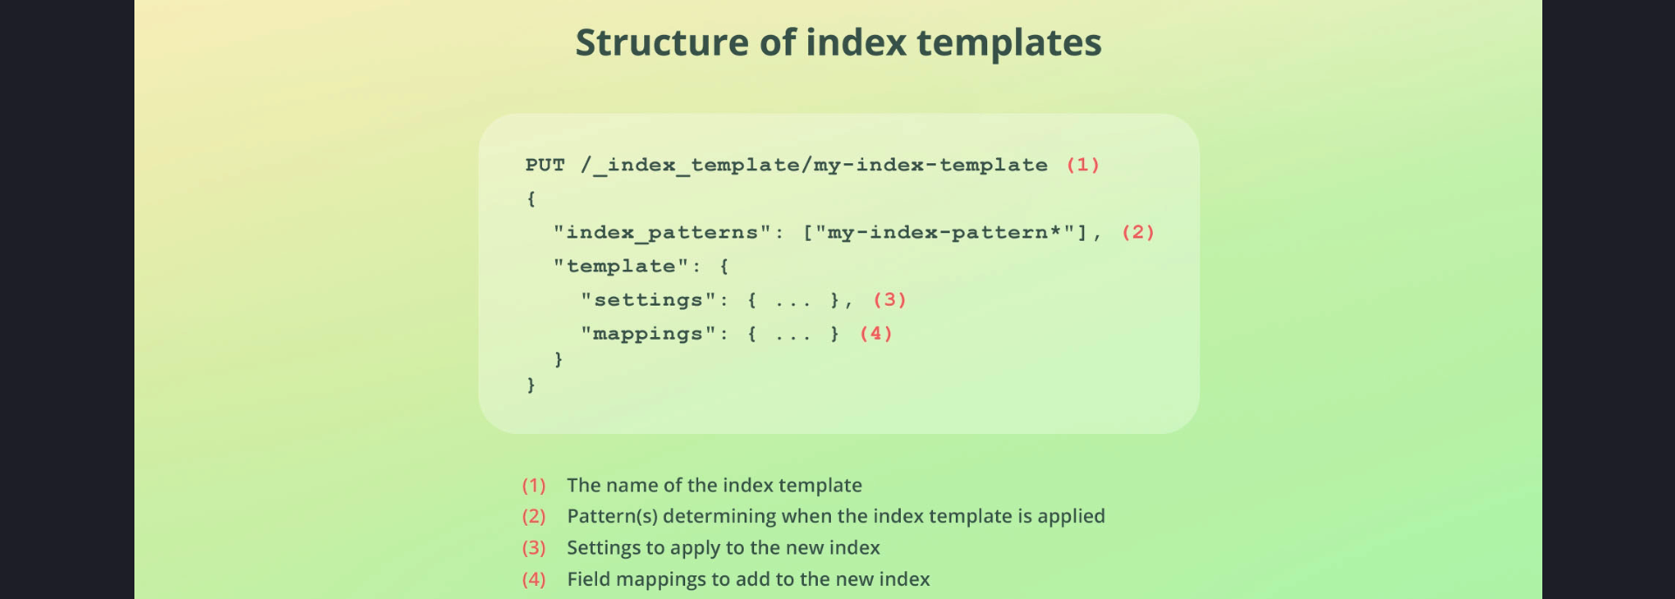

To create a new index template, send a PUT request to the desired endpoint, where the last part is an arbitrary name for the index template. The general structure of an index template includes:

* - `index_patterns`: An array of wildcard expressions that match index names.
* - `template`: Contains index settings and field mappings.

## Example of an Index Template

Here is an example index template that includes field mappings for storing HTTP access logs, such as for nginx or the Apache web server. It also configures index settings, such as the number of shards (set to 2) and disables type coercion.  
 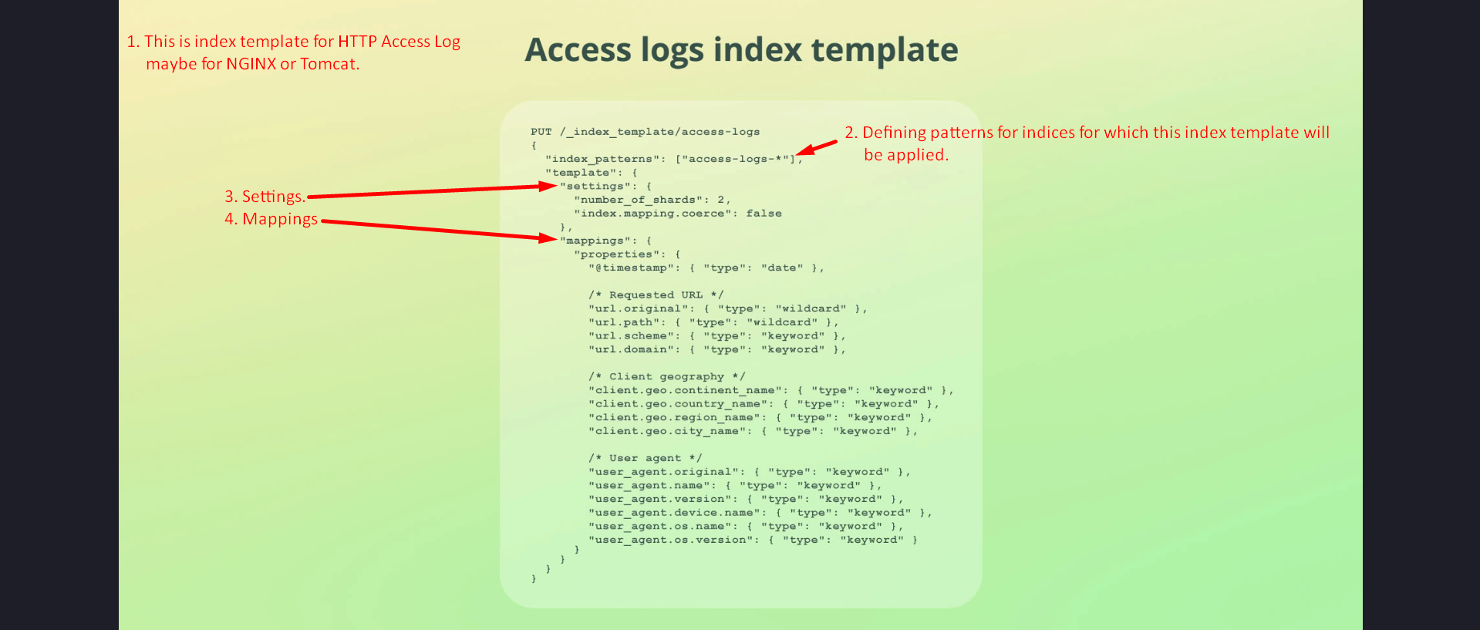

## When to Use Index Templates

Index templates are useful when storing data across multiple indices, typically created dynamically over time. A common use case is time-based indices, such as creating a new index for each month.  
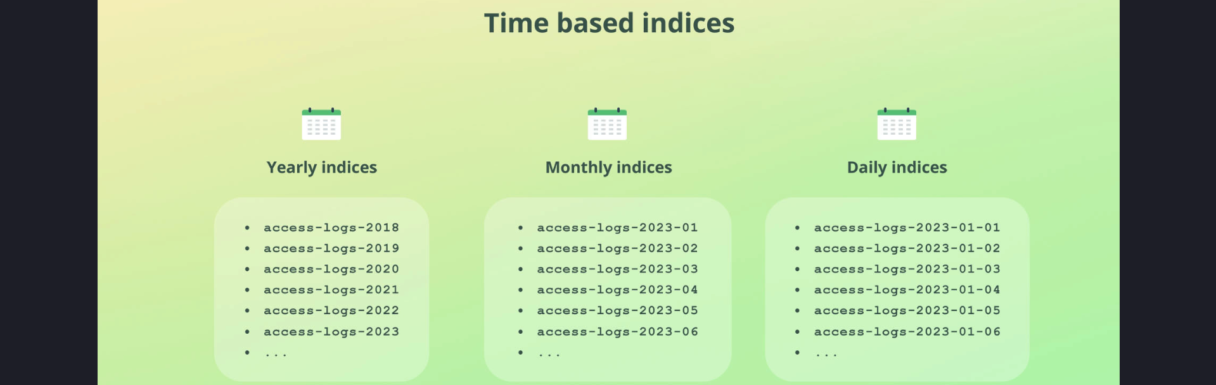  
  
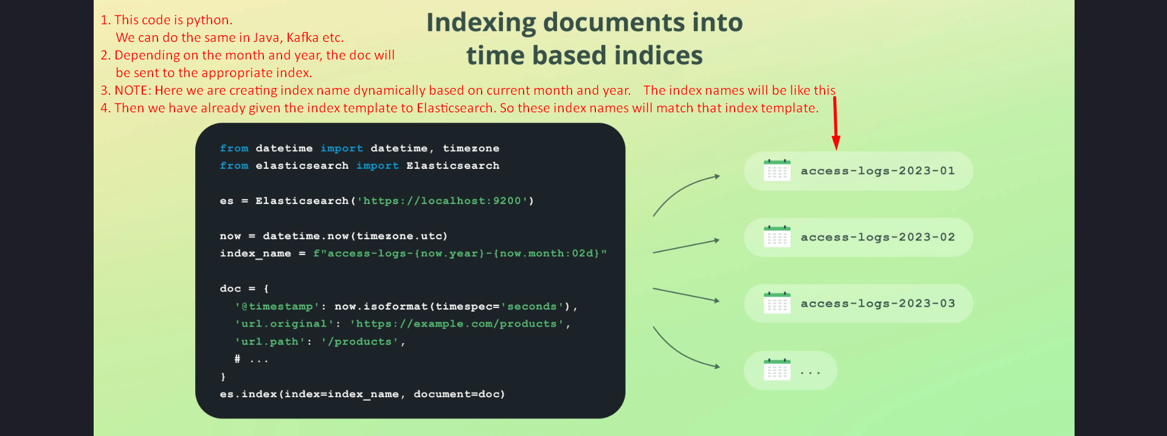

## How Elasticsearch Handles Index Templates

When a document is indexed into an index that matches an index template pattern, Elasticsearch:

1. 1. Checks if the index exists.
2. 2. If not, searches for a matching index template.
3. 3. Creates the index using the index template if found.
4. 4. Applies default settings if no template matches.
5. 5. Indexes the document into the newly created index.

**Let’s see how it works via Kibana.**

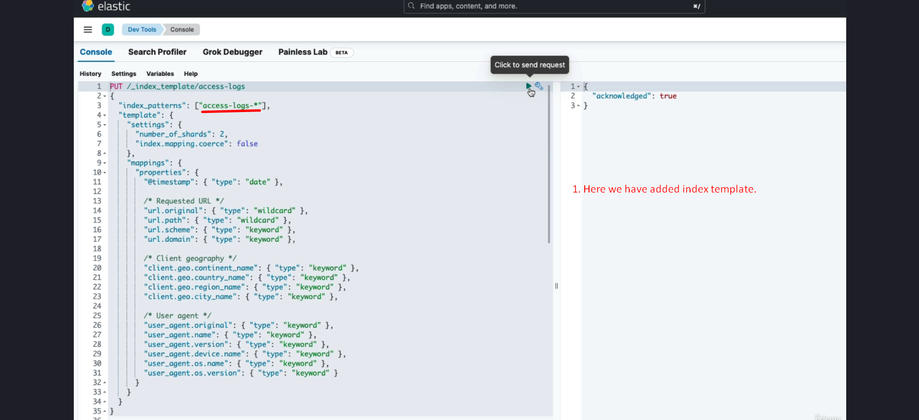

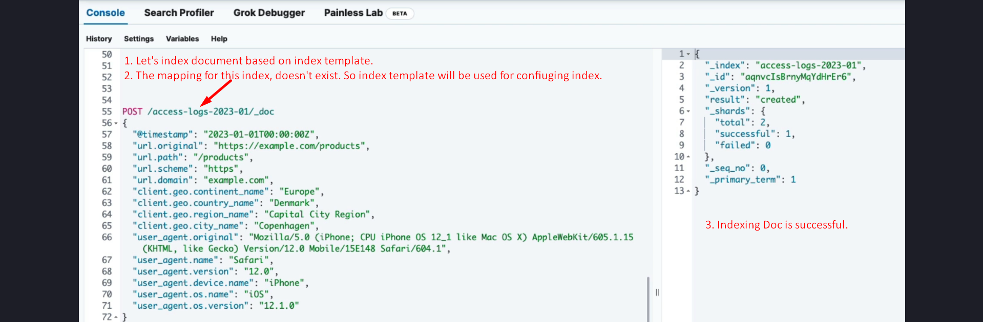



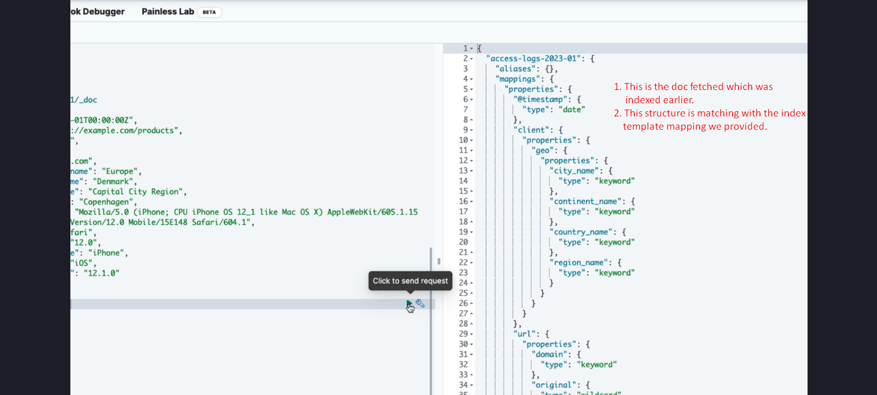

So index template is convenient for indices created periodically like this (name+year+month).

We don’t need to run scheduler job to create index for each month.

Index template is applied, it doesn’t matter we creating index during indexing a doc or creating index manually.



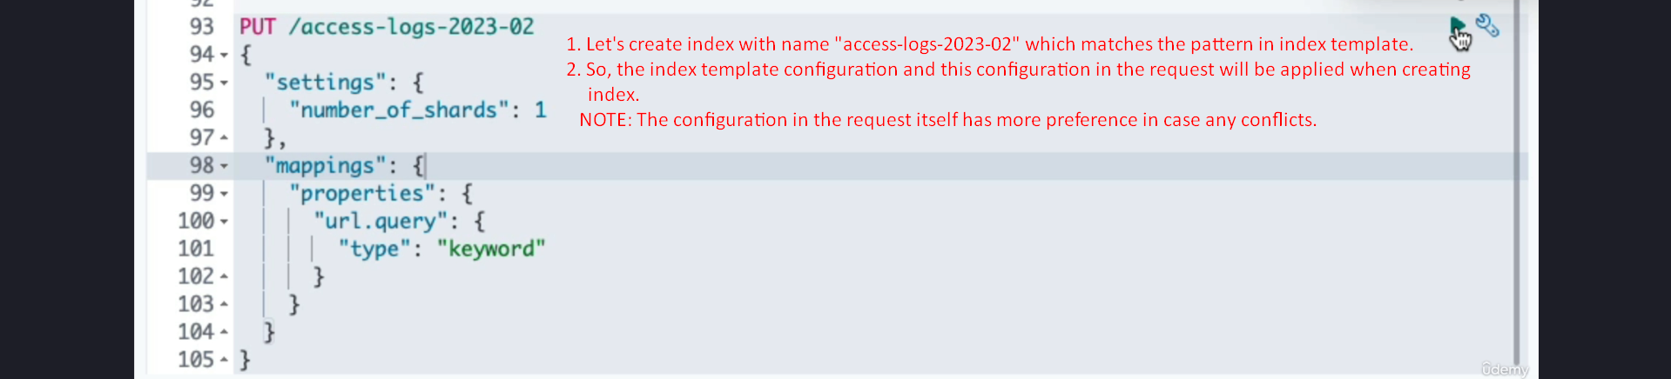

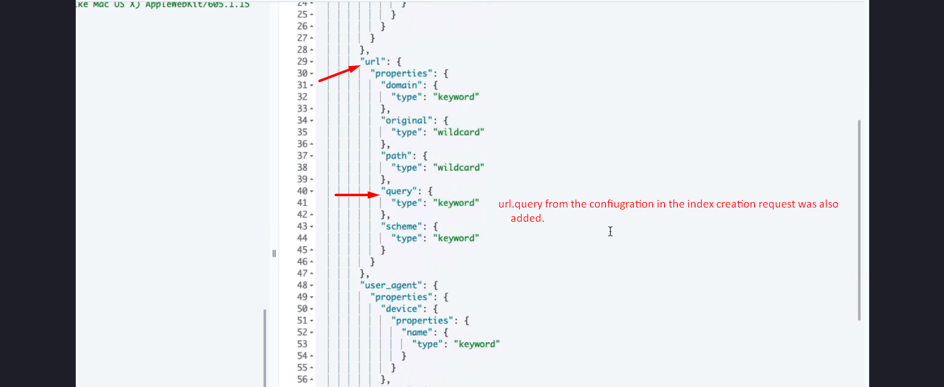

## Updating and Deleting Index Templates

Updating an index template is the same as adding one because both use the PUT HTTP verb. Deleting an index template requires a DELETE request. It's important to note that these operations do not affect existing indices; they only apply to indices created after the template is updated or deleted.

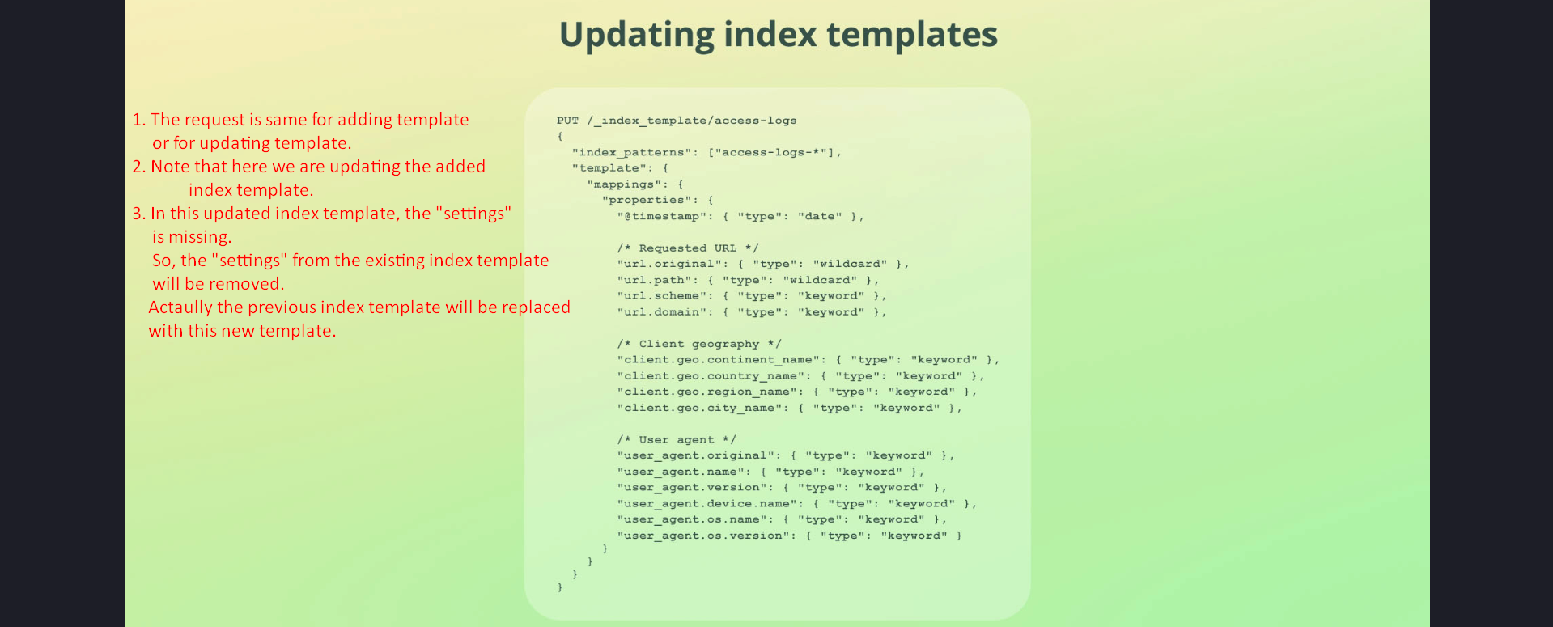



## Priority and Overlapping Index Patterns

By default, overlapping index patterns are not allowed. To manage this, Elasticsearch allows specifying a priority for each template. Higher priority templates take precedence when multiple templates match an index.

  
  
  
  
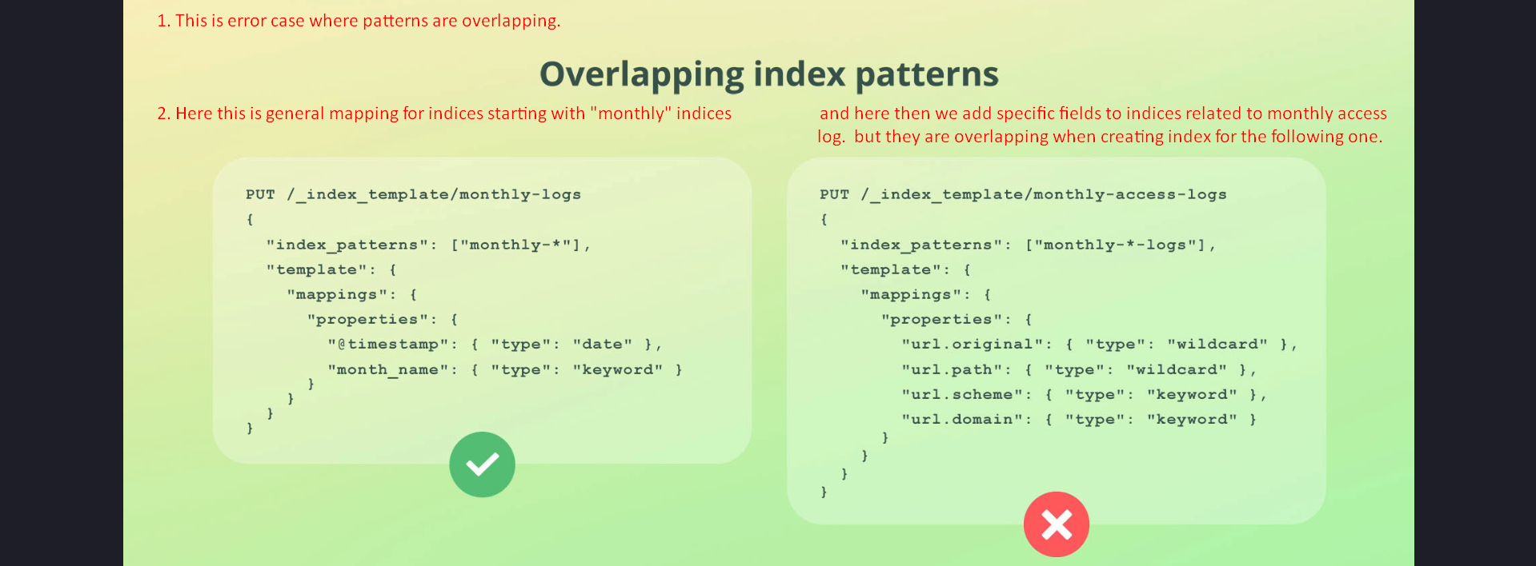  
  
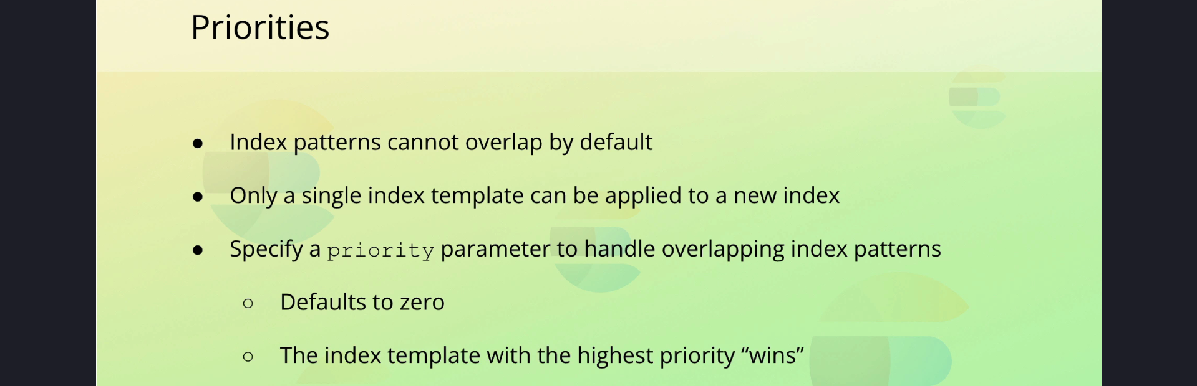  
  
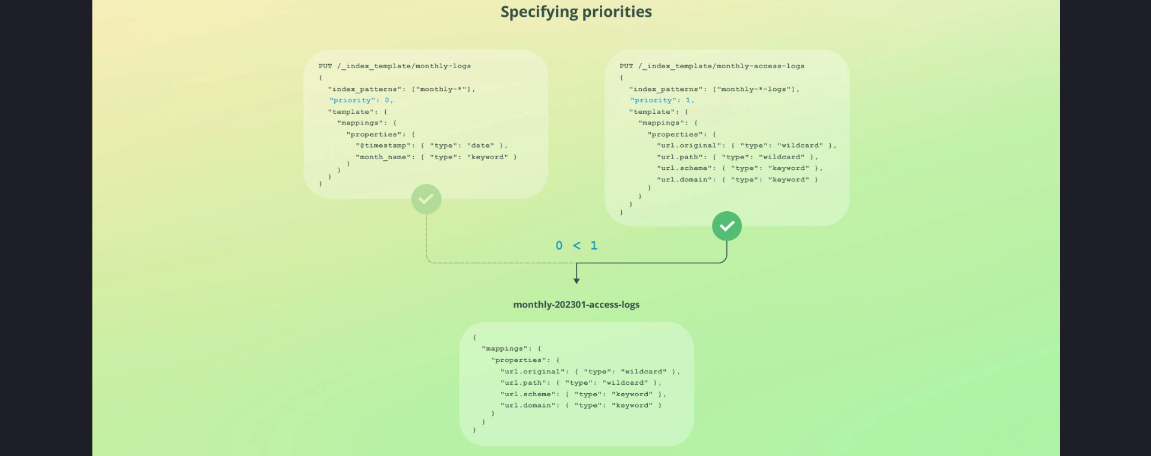

## Conclusion

Index templates simplify managing dynamic index creation by applying predefined settings and mappings. While useful for time-based or dynamically created indices, they are not needed for single index creation. By understanding index templates, their structure, and how to manage them, you can streamline your Elasticsearch workflows.

